**CUSTOMER CHURN ANALYSIS**

**Enhancing Banking Retention Strategies**

**Objective**: The objective of this project is to conduct a comprehensive analysis of customer churn within an ABC banking institution and derive actionable insights to improve customer retention and loyalty. Through data-driven exploration and interpretation, the project aims to identify key factors influencing churn behavior, such as demographic characteristics, product usage, and geographic location. By understanding the underlying patterns and trends, the project seeks to formulate targeted strategies and recommendations to mitigate churn, enhance customer engagement, and drive long-term business success.

**Python Notebook:** In addition to the insights presented in this report, I am pleased to provide access to the Python notebook used for data analysis and model building. The notebook serves as a comprehensive record of my methodology, including data preprocessing, exploratory data analysis (EDA), model development, and evaluation. By sharing the notebook, I aim to offer transparency in my analytical process to delve deeper into the details of my methodology. Below, you'll find the link to the notebook hosted on GitHub, where you can explore the code, visualizations, Model Building in detail.

**Github Link:** <https://github.com/komatineniapoorva/Project5-Customer-Churn-Analysis>

**Dataset Description:**

The dataset from ABC Multistate bank contains information about customers and their interactions with the bank. Here's a brief description of each column:

1. Customer ID: Unique identifier for each customer. This column is not used in the analysis.
2. credit score: Numerical representation of a customer's creditworthiness.
3. country: The country where the customer resides.
4. gender: Gender of the customer.
5. age: Age of the customer.
6. tenure: Number of years the customer has been with the bank.
7. balance: The current balance in the customer's account.
8. products number: Number of bank products the customer posess.
9. credit card: Indicates if the customer holds a credit card (1) or not (0).
10. active member: Indicates if the customer is an active member (1) or not (0).
11. estimated salary: Estimated salary of the customer.
12. churn: Target variable indicating if the customer has left the bank (1) or not (0) during a specific period.

This dataset allows for analysis and modeling to understand customer behavior and factors influencing churn, aiding in the development of strategies to retain customers and improve customer satisfaction.

**Observations:**

1. Customer Overview:
   * We have a total of 10,000 customers, out of which 5,151 are active members.
   * The gross balance across all accounts amounts to $765,000,000.
   * Majority of customers (7,055) are credit card holders.
   * Churn analysis indicates that 2,037 customers have left the bank during the specified period.
2. Churn Analysis:

* Gender-wise churn distribution shows that females account for 55% of churn cases, while males account for 44%.
* Customers with credit cards exhibit a lower churn rate, with zero churn observed among 6,000 credit card holders.
* Churn rates vary across different product numbers and countries, with certain products and regions experiencing higher churn rates.

1. Detailed Analysis:

* Balance analysis by gender and churn status indicates differences in churn behavior between males and females.
* Credit score varies across countries, with Germany and Spain exhibiting slightly higher average scores compared to France.
* Active members tend to utilize credit cards more frequently compared to churned members, suggesting potential strategies for customer engagement.
* Salary and balance distribution by age highlights fluctuations in account balances across different age groups.
* Credit score trends over a 10-year tenure period indicate a decline in credit scores among customers staying 5-7 years.

**DashBoard:**

[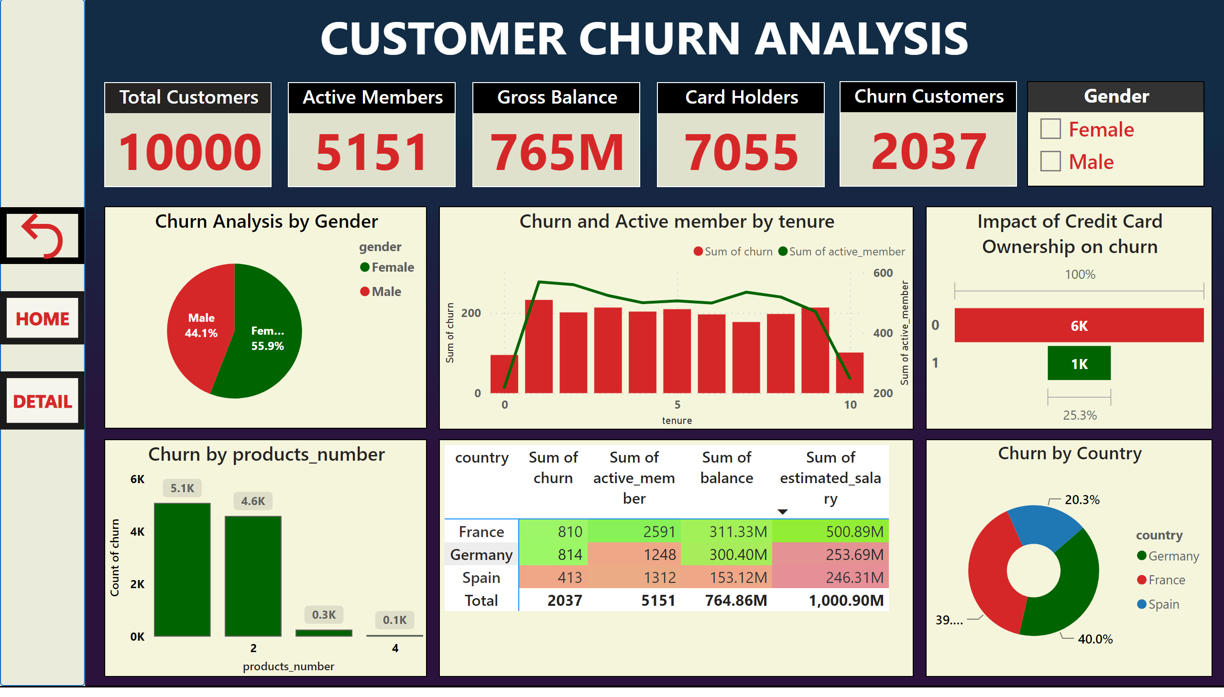](https://app.powerbi.com/groups/me/reports/7495e20d-1698-4174-929c-f4628512f5c8/?pbi_source=PowerPoint)

[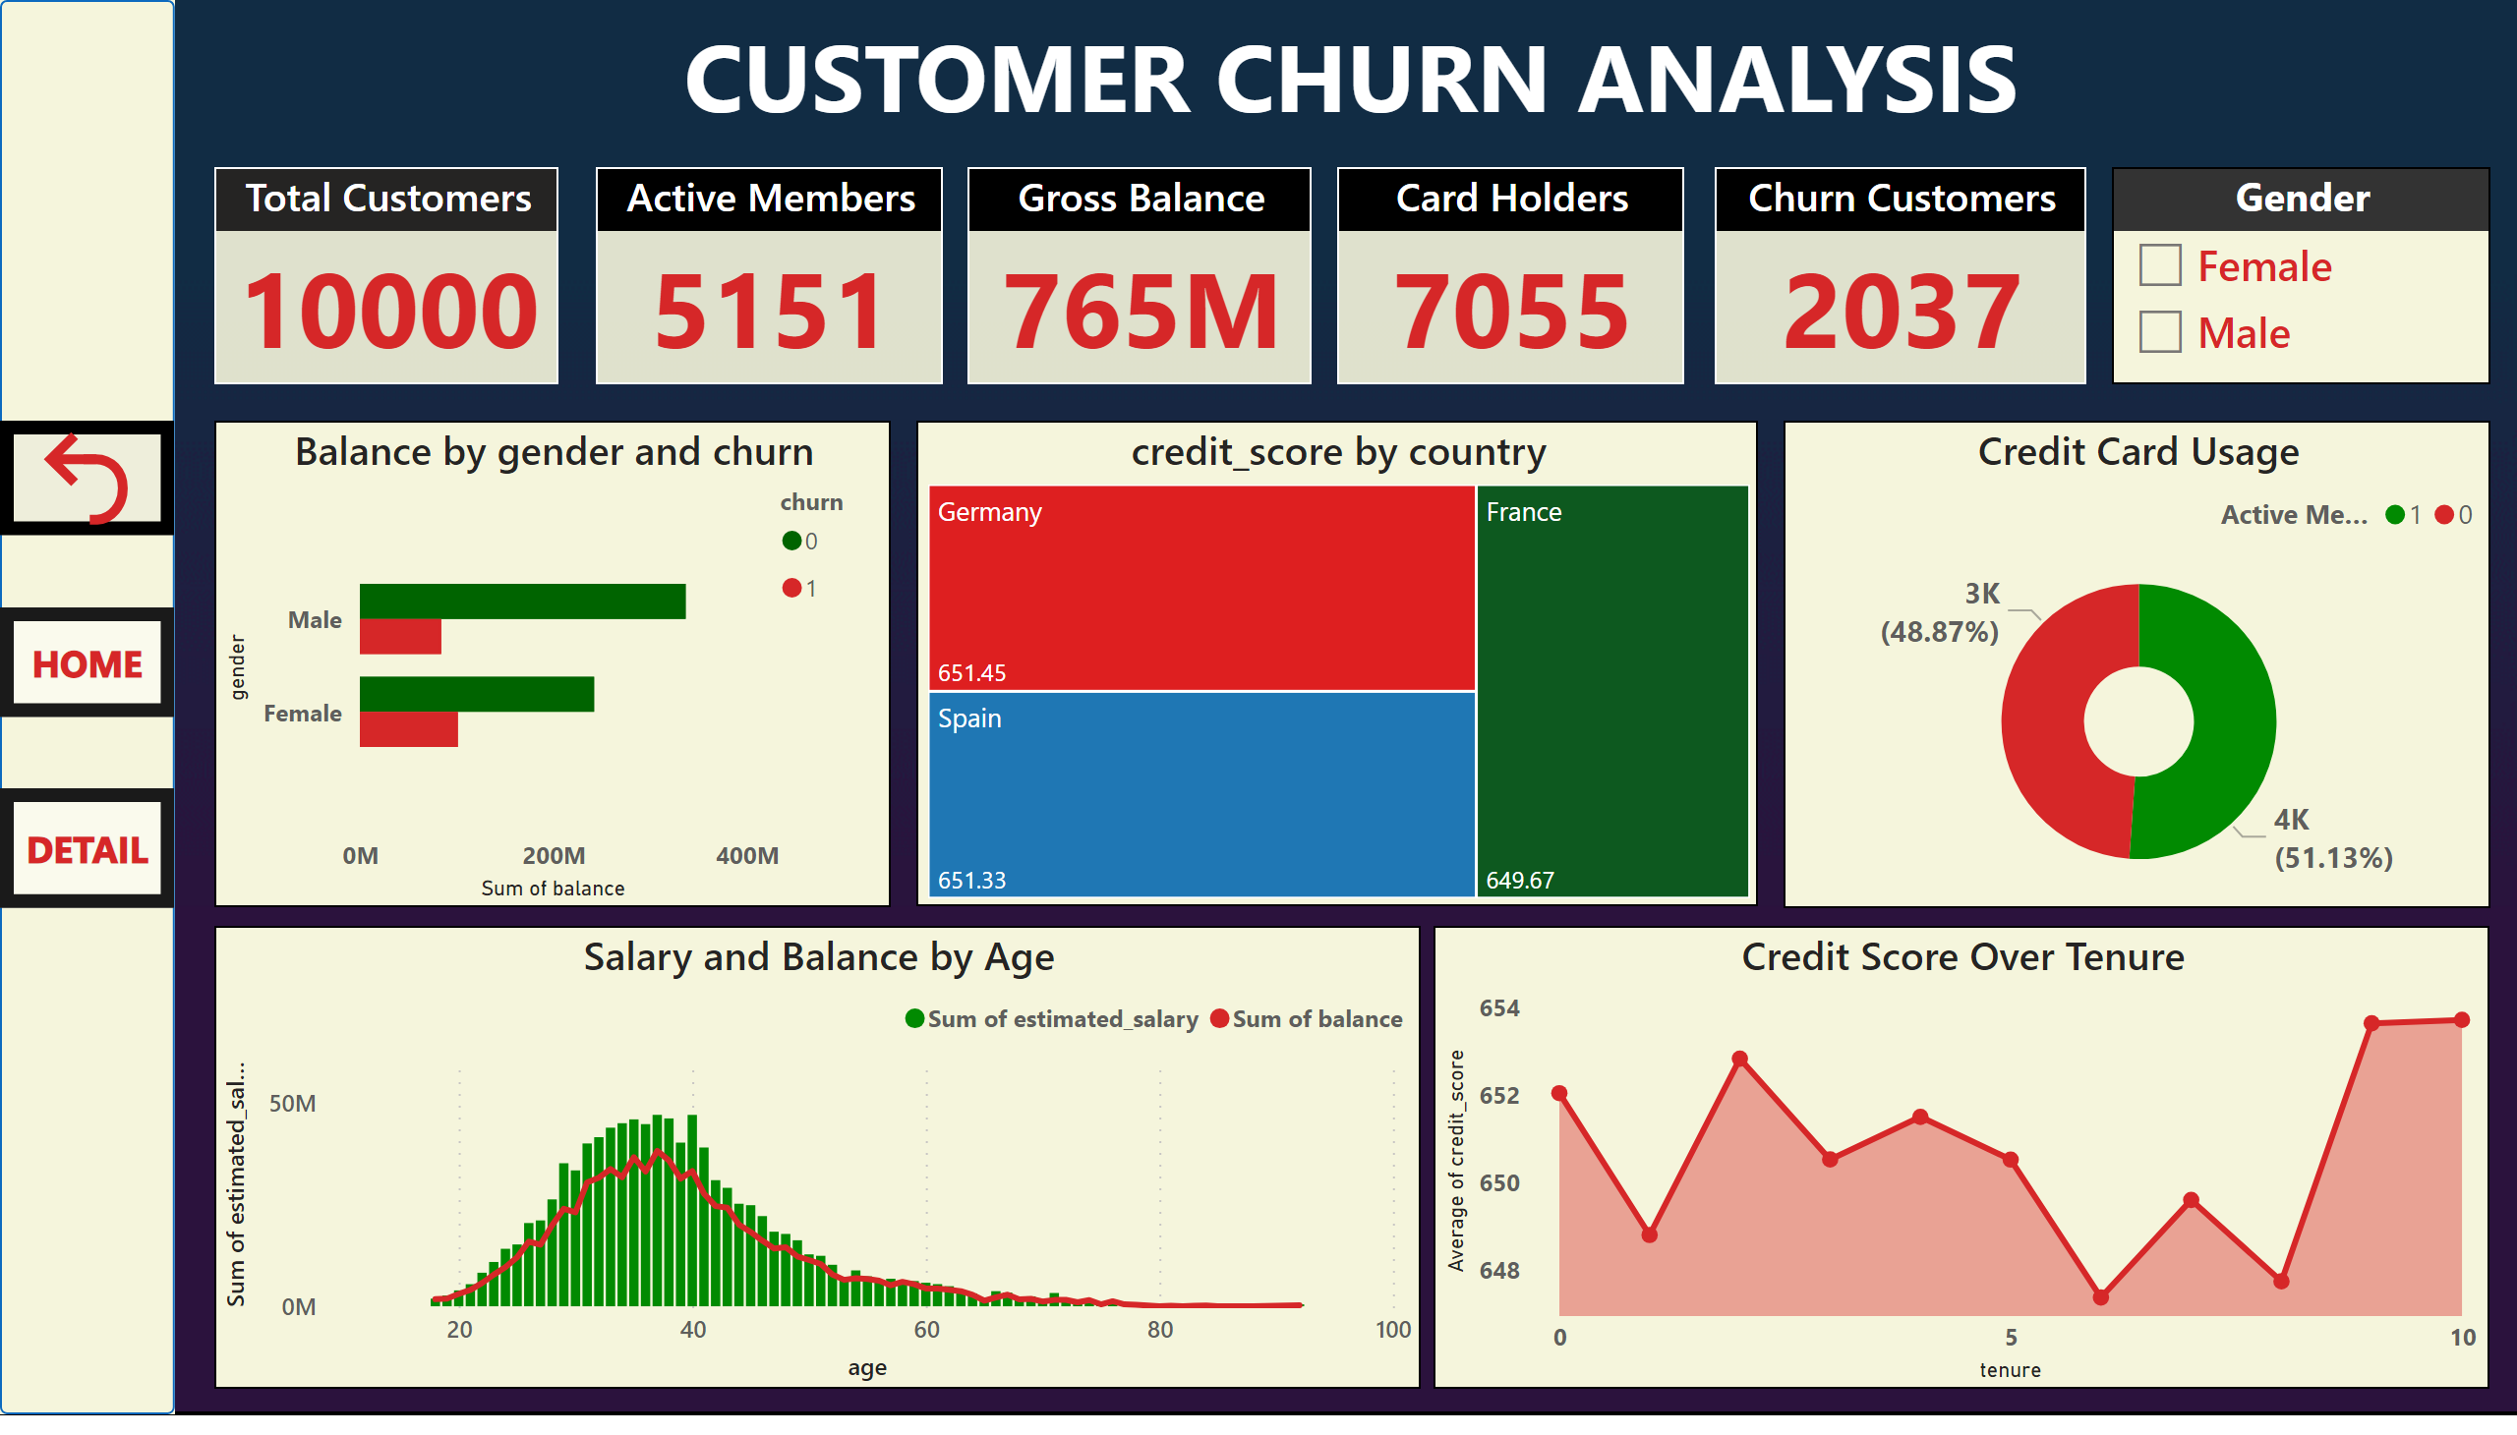](https://app.powerbi.com/groups/me/reports/7495e20d-1698-4174-929c-f4628512f5c8/?pbi_source=PowerPoint)

**Recommendations:**

1. Enhanced Customer Engagement:

* Develop specialized initiatives, such rewards programs, and customized incentives, to promote credit card usage among existing cardholders.

1. Product Optimization:

* Evaluate consumer feedback and product performance to maximize offerings, reduce attrition, and boost satisfaction among customers.

1. Geographic Focus:

* prioritize regions with higher churn rates, such as Germany and France, for targeted retention efforts and service improvements.

1. Age-Specific Initiatives:

* Develop age-specific campaigns and services to cater to the financial needs and preferences of different age demographics, aiming to improve customer loyalty and retention.

By leveraging these insights and recommendations, the bank can effectively address churn challenges, enhance customer retention, and foster long-term growth and profitability.